Optimisation Design Brief

The texture loading needs optimisation because as the program is now, whenever a critter gets made it loads a texture, and when one gets destroyed it unloads a texture. Because of how often this happens, the program is slowed down.

To fix this, I implemented a hash table that takes in Texture2Ds, which stores the already loaded textures for the critters and the destroyer. I chose to do this as a hash table seemed like the most efficient way to store the textures. From there, I changed the function for making critters so that rather than taking in a character array, which would have been the name of the texture file, it takes in the loaded Texture2Ds from the hash table. I chose to do this because it means that now instead of loading textures every time a new critter is made, textures are only loaded once at the start of the program. Finally, I changed the critter’s destroy function so that it no longer unloads textures, and instead doesn’t unload at all. I chose to do this as the textures already get unloaded when the window is closed.

Object Pool: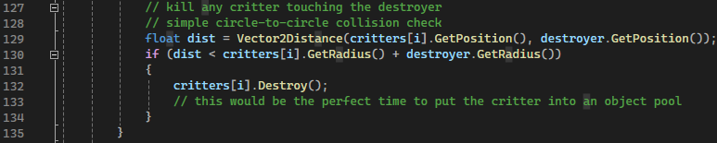

This part of the code needs optimising, as without an object pool, there is a risk of memory fragmentation, where space that should be available to store a critter is unavailable. Adding an object pool would allow the program to take critters from a list of critters, instead of frequently making new ones.

To do this I made a new class for object pools, which acts as an array of critters. I did this so that the critters can be stored inside of it. From there, I made a function for allocating and deallocating, so that critters can be added to the object pool. I implemented the allocate function at the end of the for loop that creates critters and the for loop that respawns critters. This is so that when critters are created, they are added to the object pool. I implemented the deallocate function at the end of the if statement that destroys critters touching the destroyer. This is so that when critters are destroyed, they are removed from the object pool.

